**Release : 555 Testing**

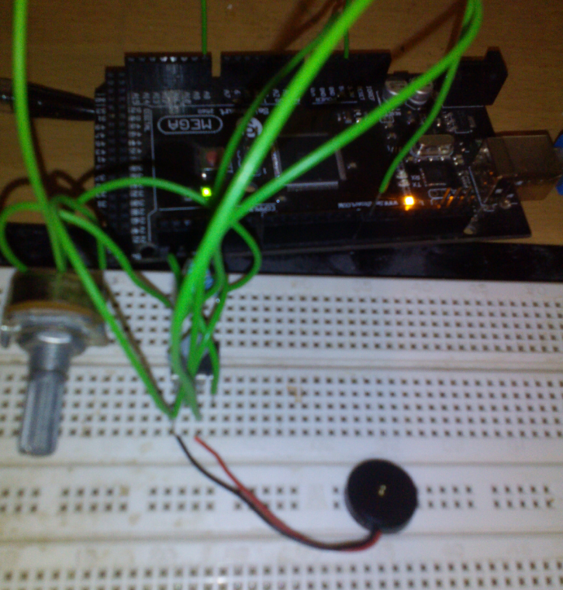I have to say I have stunned myself with cheapness of the design for this machine, the sound effects. It’s the world’s cheapest VCO. I mean, it’s really cheap. I must’ve saved myself all of 70p by not using a 4046 or 566 chip here. Mind you I didn’t know they existed when I was fourteen.

If you’ve ever heard the RCA Studio 2 console, you’ll know its only sound effect is a warpy sound. This is the same electronics at work.

Generated by the utterly ubiquitous NE555 timer chip. This is caused by a big capacitor across pin 5, which causes the pitch to vary as it charges up.

Imagine playing Pacman to the sound of a whining donkey, or the latest Cheryl Cole* record (I can’t remember her French name, something like Scoffini-De-Baguette or something) you’ll get the idea of it, and wish you were deaf, unless you picked the donkey obviously.

What I’ve done, apparently, is to put a D/A ladder on F2, F1 and F0, which previously weren’t In use and wired that to pin 5 of a classic NE555 Astable circuit with R1 = R2 = 10k, C1 = 10nf.

That’s actually what the picture is. There’s a 555, a couple of resistors and a capacitor under the green wire (which isn’t as big as it looks), you can see the buzzer and the potentiometer I’m using to vary the voltage on Pin 5, and an Arduino is monitoring that voltage and the output pin.

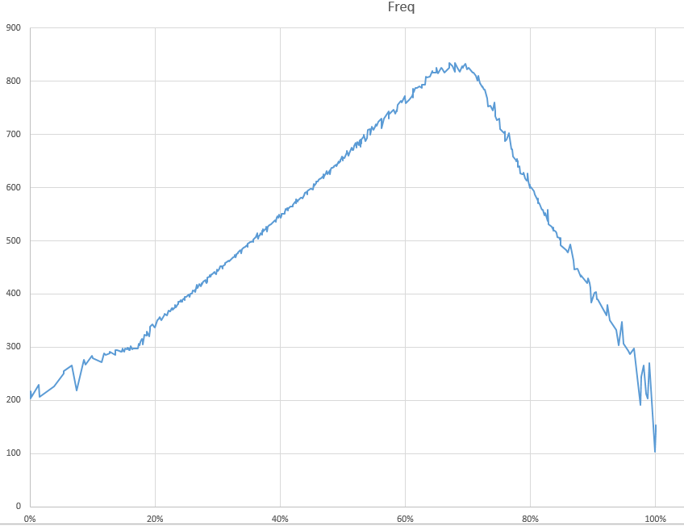I did this because whilst I could find lots of what look like University level experiments using the 555 control (seriously ? this took me like 10 minutes of which 5 was trying to read the chip label to see it was a 555 – the white marking had faded and it was with a pile of 741s) no-one actually seems to have worked out how the frequency varies with the voltage. So I’ve done it. (Actually I did this test in November, I was fascinated to see if it would work when I first looked at this design). I appear to have originally thought it was linear passing through the origin.

As you can see, the voltage is fairly linear – the horizontal access is % of Vcc, the vertical access is the frequency. It (as I read) operates up to 2/3 x Vcc and then inverts – I think on each side of the peak it is affecting different charging cycles.

Using an R/2R simple D->A gives the following frequencies. Which are actually quite a useful spread of frequencies to work with. It’s never going to play Beethoven’s fifth, but it’s not useless.

|  |  |  |  |
| --- | --- | --- | --- |
| **Binary** | **Decimal** | **Percentage** | **Frequency** |
| 000 | 0 | 0 | 200Hz |
| 001 | 1 | 12.5 | 280Hz |
| 010 | 2 | 25 | 390Hz |
| 011 | 3 | 37.5 | 520Hz |
| 100 | 4 | 50 | 650Hz |
| 101 | 5 | 62.5 | 780Hz |
| 110 | 6 | 75 | 730Hz |
| 111 | 7 | 87.5 | 447Hz |

The problem with this design is there is no *off*. I seem to have had the impression from what I’ve written that 000 was going to be off, that this Voltage:Frequency ratio was linear ; it Is (up to 2/3 Vcc) but not to zero.

I will amend the diagram so that it detects 000 manually and uses that to turn the sound off. (Cheating ! Well if I *didn’t* it would play that bl**dy note every single second).

There’s no actual construction details or anything, the diagrams are just that, annotated circuit diagrams. Practically it would make sense to put this and the cassette I/O on the main board as they are just a few components.

This would mean the computer had three boards ; the main board, the RAM and ROM board, and the Video board.

* Note for Americans. The nearest equivalent Is Kelly Clarkson singing a duet with an angle grinder.